**Annual Progress Report to:**

**Iowa Department of Natural Resources**

**Common carp and bigmouth buffalo population evaluation in shallow natural lakes**

Submitted by

Martin Simonson and Michael J. Weber

Department of Natural Resource Ecology and Management

Iowa State University

February 2020

**Introduction:**

Common carp is a widespread invader worldwide that has been described as an ecosystem engineer due to its large-scale ecosystem disturbances (Koehn 2004; Weber and Brown 2009). Common carp are associated with physical, chemical, and biological alterations to shallow aquatic systems (Weber and Brown 2009). Direct effects of common carp (e.g., decreased water clarity and aquatic macrophyte coverage, increased suspended nutrient availability) can result in shifts in aquatic ecosystems between alternative equilibria from a heterogeneous, clear macrophyte-dominated state to a homogenous turbid, plankton-dominated state (Scheffer et al. 2001; Weber and Brown 2009), which may indirectly result in changes in native fish assemblages and food web dynamics (Jackson et al. 2010; Weber and Brown 2011).

Bigmouth buffalo is a native planktivore that is widely distributed in lakes and rivers across the Midwest. Despite their commercial value, they are often considered a ‘rough fish’ by anglers, similar to common carp. Fishery managers are also concerned about the potential role bigmouth buffalo may play in regulating water quality in shallow lakes. Bigmouth buffalo consume primarily zooplankton (McComish 1967) and anecdotal information suggests that they can achieve high densities in some instances. Thus, bigmouth buffalo may regulate shallow lakes through trophic cascades by decreasing zooplankton populations, thereby resulting in increases in algal blooms, similar to bluegill (Carpenter et al. 1985; Carpenter and Kitchell 1988). However, sparse population information exists for buffalo and their potential role in regulating food web dynamics and water quality in shallow lakes is unknown.

One of the most basic data needs for managing fisheries is a sampling technique that can accurately assess fish abundance. Currently, little information exists regarding the ability of traditional fisheries gears for assessing the abundance of common carp or bigmouth buffalo. Work conducted in Minnesota suggests that electrofishing is a reliable metric for assessing common carp abundance but was conducted in small systems (Bajer and Sorenson 2012). Variation in lake size, environmental conditions (e.g., conductivity, temperature), or carp density could influence the utility of standardized sampling gears for indexing carp population abundance. In Iowa, electrofishing and bottom trawl CPUE was positively related to carp density in Lost Island Lake (J. Meerbeek, Iowa DNR, unpublished data). However, it is unknown whether or not this relationship is applicable to other lakes across a gradient of carp densities and lake sizes.

A variety of techniques have been applied to control common carp and buffalo populations, including mechanical removal (e.g., netting and trapping), toxicants, water level manipulation, fish barriers, biotechnology, and immunological methods (Brown and Walker 2004; Weber and Brown 2009). Whole-lake chemical piscicide applications have been successful at reducing or eliminating invasive fish populations in small systems, but their use is limited by lake size, costs, and public concerns about effects on non-target fishes and risks to human health (Meronek et al. 1996). In contrast, mechanical removal of invasive species provides a species-specific alternative to chemical reclamation (Hein et al. 2006; Zipkin et al. 2008), but formal holistic evaluations of its effectiveness at controlling invasive populations are scarce. The most widely attempted mechanical method to control common carp populations is commercial fishing using large seine nets (e.g., Weber and Brown 2009; Colvin et al. 2012). However, supporting population dynamic data for common carp is lacking and population-level effects of mechanical removal are limited.

**Objectives:**

1. Assess the utility of electrofishing to assess common carp and buffalo abundance.
2. Monitor changes in common carp and buffalo abundance and biomass in response to harvest.
3. Monitor sportfish community.

**Methods:**

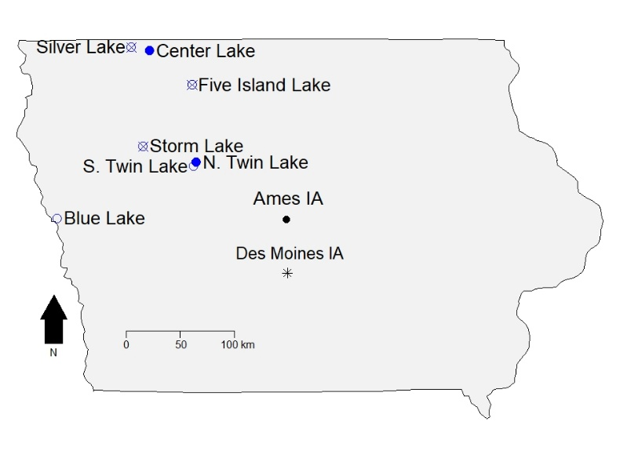Seven shallow, natural lakes of Northwest Iowa are included in this study (Figure 1). Sampling by Iowa State University (ISU) will be primarily conducted on Center (220 acres), Five Island (973 acres), Storm (3,097 acres), and Silver (Dickinson; 1,040 acres) lakes located in northwestern Iowa starting in spring 2018 through the conclusion of the study. Iowa DNR will primarily sample fish at North (453 acres) and South (600 acres) Twin lakes and Blue Lake (269 acres). Lake maps are provided in Appendices A-G. Both ISU and Iowa DNR have agreed to an exchange of labor so that each lake is visited by both entities each year and personnel can be moved to where they are needed the most.

**Figure 1:** Map of seven study lakes included in the common carp and bigmouth buffalo population study in Northwest Iowa. Study lakes either experienced incentivized commercial harvest (filled circles), traditional commercial harvest (crossed circles), or were reference systems with no harvest (open circles) in 2019.

Commercial fishers will harvest common carp and buffalo in Center, Five Island, North Twin, Silver, and Storm lakes during spring and winter of 2018, 2019, and 2020. In 2018, common carp and buffalo were commercially harvested from Center, Five Island Lake, and Silver lakes. In 2019, commercial fishing contracts for Center and North Twin lakes include an incentive for meeting common carp harvest quotas set by Iowa DNR based on 2018 biomass estimates. The incentivized contract for North Twin Lake was extended at no cost to the commercial through May 21, 2020 as commercial anglers exceeded bigmouth buffalo quotas and will continue to harvest fish through the cold water season of spring 2020. The incentivized contract for Center Lake in 2019 was not a success, and contractors accepted a penalty instead of continuing harvest effort to meet common carp quotas, and no commercial fishing contract was implemented in Center Lake for 2020.

Traditional (non-incentivized) commercial fishing contracts will be issued for Five Island, Silver, and Storm lakes, with South Twin Lake and Blue Lake serving as reference systems without harvest (Figure 1). Contracts will be renewed annually with quotas for incentivized harvest lakes adjusted based on updated estimates. To assess changes in common carp and bigmouth buffalo abundance and biomass, Iowa DNR and Iowa State University personnel have been conducted a capture-mark-recapture analysis. Common carp and bigmouth buffalo are tagged with a self-piercing operculum tag and given year-specific fin clips (e.g., 2017: right pelvic, 2018: left pectoral, 2019: left pelvic, 2020: anal). A subset of common carp (~100 fish per lake) have not be tagged and instead will be measured for length and weight and euthanized to remove aging structures (e.g., otoliths, dorsal spines). After fish have been marked, ISU and Iowa DNR return to each lake during spring and summer to recapture fish using pulsed DC electrofishing. The total number of carp and buffalo captured and number captured with a tag and/or specific fin clip will be recorded for each electrofishing run to estimate tag loss and population abundance. Sampling location and effort for each gear will be recorded to calculate catch per unit effort (CPUE; number per hour). Annual population and biomass estimates for each year will be calculated for all lakes using the modified Schnabel population estimate and length-specific weight estimates, respectively.

Fish sampling was primarily conducted by boat electrofishing. Beginning in May of each year, standard electrofishing transects were sampled systematically during the first half of the month and continued to be sampled repeatedly in the beginning of every month until October or later. Additional boat electrofishing occurred in the latter half of each month between May and October/November of each year, where the sampling crew could use their own discretion on sampling locations in each lake. Under this sampling design, our goal is to sample each lake at least 15 times per year.

In addition to electrofishing, ISU and IA DNR have coordinated with commercial harvesters in the spring to tag common carp and bigmouth buffalo in each lake. Contracts with the commercial anglers stipulate they will assist in capturing fish to tag, and in lakes without commercial fishing contracts, fee-for-service agreements have been implemented to compensate commercial fishing operations for their time and equipment. This biomass harvest estimates and return of tags from marked fish that are harvested will also be requirements of the commercial fishing contracts in these lakes.

Changes in annual biomass estimates will be compared to harvested biomass of carp and buffalo to estimate the level of harvest in each lake. Harvest occurring between sampling seasons (approximately October to May each year) is combined into a single sampling season reflective of both calendar years. For example, fish harvested from a lake in December 2017 and again May 2018 will be classified as part of the 17-18 harvest season. Therefore, a given year’s population and biomass estimates represent common carp and bigmouth buffalo abundances after the conclusion of the previous season’s commercial harvest. Common carp and buffalo population indices (e.g., CPUE, PSD, *Wr*) will be monitored through time to evaluate each species’ changes in response to commercial fish removals. In addition, growth curves and recruitment will be monitored at each lake to describe the effect of harvest on these populations and to test for causal relationships between harvest and changes in growth rates for carp and buffalo.

Spring electrofishing and fall trap nets are conducted in each lake to assess fish communities prior to and following carp and buffalo removals. Number of electrofishing runs and trap net nights vary based on lake size in accordance to Iowa DNR standardized lake surveys. A subset of captured fish are measured (TL mm) and weighed (g), aging structures (e.g., scales, spines) are removed, and all other fish are released alive. Sport fish population indices (e.g. CPUE, PSD, Wr) are being monitored through time to evaluate changes in response to carp and buffalo removal.

**Task 1: Common Carp and Bigmouth Buffalo Monitoring**

Capture-mark-recapture (CMR) sampling for common carp and bigmouth buffalo population estimates began at four of the seven lakes in 2017 (Blue, Center, North and South Twin) and expanded to all seven study lakes in 2018 and 2019. The primary sampling method was boat electrofishing. However, commercial fishers also assisted ISU and Iowa DNR with collection of fish with seine nets in five of the study lakes in 2018 (Center, Five Island, North and South Twin, and Storm). In 2019, commercial fishing contractors assisted with tagging fish in North Twin and Five Island lakes. Fyke nets were deployed for one night at multiple locations within each lake in fall 2018 and 2019. A summary of the total catch by gear of both species in each lake is presented in Figure 2.

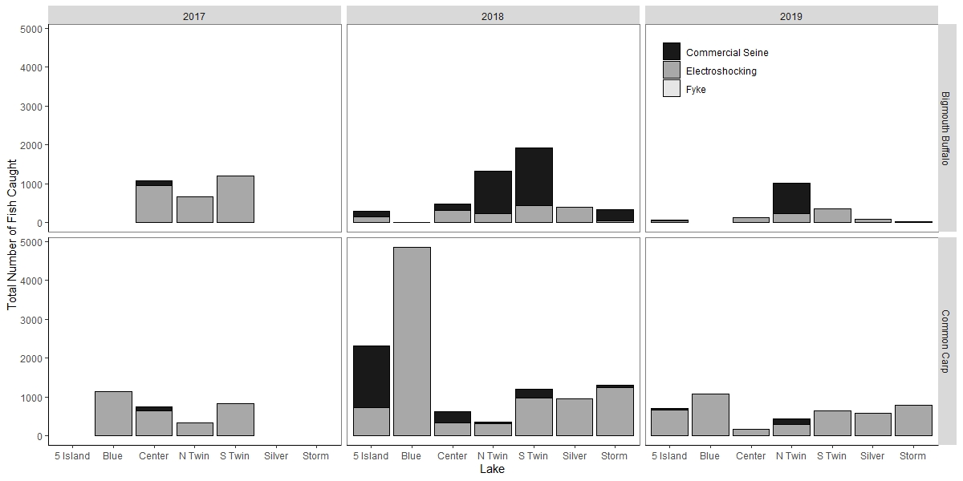

**Figure 2**. Total number of bigmouth buffalo (top) and common carp (bottom) caught in each study lake from three different gears used from 2017 to 2019 (left to right).

Commercial seining augmented total catch substantially in some instances. However, this sampling method was highly species-selective. Commercial seines captured primarily bigmouth buffalo in North and South Twin lakes, where common carp were primarily captured in Five Island Lake. In 2019, commercial tagging assistance was primarily partial net pens of fish that the commercial fishing contractors chose to let ISU and the IA DNR tag instead of expending the labor to remove the fish from the lake. Commercial fishing contractors did not choose to exercise the contract terms for Storm Lake which stated IA DNR would pay a per-pound price for carp and buffalo caught by contractors for tagging.

Sampling via electrofishing resulted in similar numbers of fish across lakes in 2018 with the exception of Blue Lake. In 2019, electrofishing catches of bigmouth buffalo declined in most lakes while catches of common carp remained relatively consistent with previous years, except in Blue Lake, where catch declined. This is likely a result of significantly reduced effort in Blue Lake in 2019 when compared to 2018 (Table 1). Fyke nets captured few common carp or bigmouth buffalo in both 2018 and 2019.

**Table 1.** Electrofishing sampling effort, number of fish tagged, number of fish recaptured, and relative abundance (CPUE; # fish per hour) for bigmouth buffalo and common carp in 2017 - 2019.

|  |  |  |  |  |  |  |  |  |  |  |  |  |  |  |  |  |
| --- | --- | --- | --- | --- | --- | --- | --- | --- | --- | --- | --- | --- | --- | --- | --- | --- |
| Lake  Species | Sample Days | | | Electrofishing Effort (hh:mm) | | | Fish Tagged  (all gears) | | | | Recaptures | | | Mean CPUE (fish/hour) | | |
|  | 2017 | 2018 | 2019 | 2017 | 2018 | 2019 | | 2017 | 2018 | 2019 | 2017 | 2018 | 2019 | 2017 | 2018 | 2019 |
| Blue  Buffalo  Carp | 11 | 29 | 12 | 16:20 | 27:56 | 13:44 | | 0  1,039 | 1  5,029 | 0  1,077 | 0  7 | 0  162 | 0  19 | 0  80 | 0  194 | 0  83 |
| Center  Buffalo  Carp | 13 | 19 | 19 | 19:26 | 23:29 | 26:07 | | 2,526  1,030 | 343  522 | 133  174 | 149  51 | 12  14 | 1  8 | 102  36 | 14  14 | 10  10 |
| Five Island  Buffalo  Carp | 0 | 17 | 19 | 00:00 | 32:54 | 46:27 | | 0  0 | 163  2,164 | 57  685 | 0  0 | 4  67 | 10  0 | N/A  N/A | 4  22 | 6  16 |
| N. Twin  Buffalo  Carp | 12 | 20 | 21 | 13:18 | 19:29 | 23:56 | | 561  222 | 1,334  388 | 2,087  412 | 9  9 | 14  17 | 49  26 | 25  17 | 12  16 | 12  16 |
| S. Twin  Buffalo  Carp | 15 | 21 | 17 | 15:11 | 22:47 | 19:24 | | 1,096  721 | 1,929  1,176 | 349  678 | 71  9 | 20  29 | 2  13 | 65  42 | 21  45 | 36  33 |
| Silver  Buffalo  Carp | 0 | 20 | 16 | 00:00 | 43:32 | 31:49 | | 0  0 | 298  931 | 92  587 | 0  0 | 2  39 | 0  16 | N/A  N/A | 13  21 | 9  22 |
| Storm  Buffalo  Carp | 0 | 15 | 15 | 00:00 | 39:33 | 33:40 | | 0  0 | 339  1,176 | 20  787 | 0  0 | 0  65 | 17  0 | N/A  N/A | 1  31 | 4  26 |

Electrofishing began each year in May, with each lake being sampled at least 10 times per year. Fixed location transects were sampled at the beginning of every month, while targeted sampling occurred in the latter half of every month. Mean catch-per-unit-effort (CPUE) was calculated as the average of the number of fish captured per hour of electrofishing for both standard and targeted sampling combined (Table 1). In addition, total length (TL) was recorded for every fish sampled in 2018, and length-frequency histograms were created for both species at each of the seven lakes sampled (Figure 3).

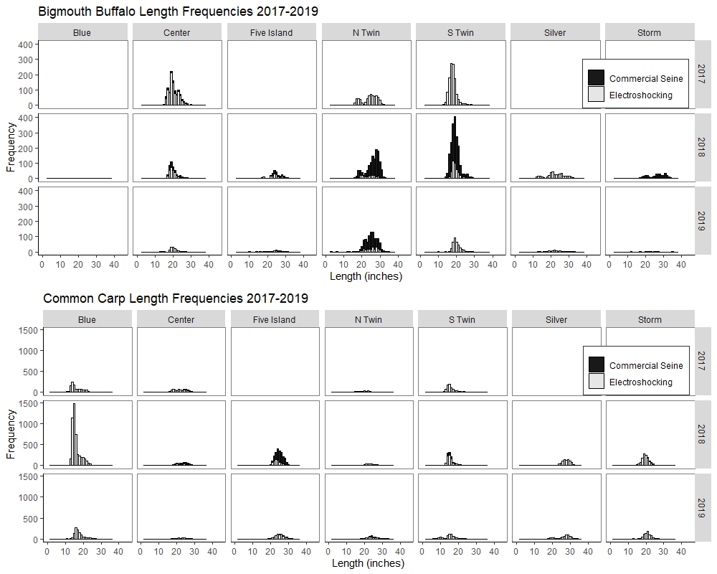

**Figure 3**. Length-frequency distributions for bigmouth buffalo (top three rows) and common carp (bottom three rows) at seven study lakes (columns) for 2017 to 2019. Stacked bars represent different catches between electrofishing (grey) and commercial seining (black). Fish are grouped into one-inch length groups. Note the different y-axis ranges between species.

Population estimates of common carp and bigmouth buffalo were calculated for each lake in each study year. Population size was estimated from the multiple CMR events using a within-year modified Schnabel method that assumes that the population is closed to recruitment and mortality within the timeframe of the study. The formula (Ricker 1975) is:

$$N=\frac{∑\left(C_{t}M_{t}\right)}{∑R_{t}+1}$$

where *N* = population estimate, *Ct*= number captured during sampling, *Mt* = total number of fish marked at large, and *Rt*= number of recaptures. The 95% confidence interval is calculated using a t-distribution with m-1 degrees of freedom, where m = the total number of sample events. Only one bigmouth buffalo was captured in Blue Lake in 2017 and another in 2018. Therefore, population and biomass estimates could not be completed for bigmouth buffalo in Blue Lake.

Biomass and biomass density for common carp and bigmouth buffalo were calculated for each lake. The total biomass was calculated by taking the total catch for each lake in 2019 and dividing the catch into bins according to length (50mm ~ 2 inches). Then, the proportion of the catch in each length bin was multiplied by the average weight for fish in that length bin. The weighted length-specific biomass estimates were then multiplied by the abundance estimate (including the lower and upper confidence interval limits). Therefore, the total biomass for each species in each lake is calculated by

$$B= \sum_{i=0}^{n}{b_{i}*p_{i}*N}$$

where *B* is the total biomass estimate of either common carp or bigmouth buffalo in each lake, *b*is the length-specific mean biomass for length bin *i*, *p* is the proportion of all fish caught that fall into length bin *i*, and *N* is the within-year modified Schnabel population estimate. Error in total biomass was calculated by using the 95% confidence interval bounds on *N* in the biomass equation. Then, biomass density was calculated by dividing the total biomass by the surface area (acres) of each lake. Estimates and 95% confidence intervals of abundance (N), total biomass (lbs.), and biomass density (lbs. per acre) for common carp and bigmouth buffalo in each of the seven study lakes are presented in Table 2.

In Center, Five Island, and North Twin lakes, sampling occurred after commercial harvest had ceased and the estimates reflect the population after spring 2019 harvest events. North Twin Lake and Silver Lake were also commercially fished in fall 2019 after ISU and Iowa DNR sampling had concluded. Therefore, 2019 biomass and biomass density estimates in Table 2 represent these populations prior to any fall commercial harvest events. In North Twin Lake, 111,400 lbs. of bigmouth buffalo and 5,200 lbs. of common carp were removed in fall 2019, while in Silver Lake 70,200 lbs. of bigmouth buffalo and 67,654 lbs. of common carp were removed in fall 2019.

Catch per unit effort for all electrofishing transects (e.g., standard locations and ad hoc site selection) in 2019 was variable based on the time of year sampling occurred, except for bigmouth buffalo in Storm Lake and Five Island Lake, where catches remained consistently low all year (Figure 4). Analysis of the overall relationship between electrofishing CPUE and population abundance/biomass are similar to preliminary data from 2017 and 2018; data show overall electrofishing CPUE is positively related to population biomass density for common carp but no significant relationship exists for bigmouth buffalo (Figure 5). Mean monthly CPUE differed between species in each lake as a function of biomass density (Figure 6 and Figure 7). The relationship between common carp biomass density and observed electrofishing CPUE was not as pronounced in each month as it was when aggregated across the entire year.

|  |  |  |  |  |  |  |  |  |  |  |  |  |
| --- | --- | --- | --- | --- | --- | --- | --- | --- | --- | --- | --- | --- |
| Table 2. Estimates and 95% confidence intervals for population abundance (N) using the modified Schnabel method, total biomass (lbs.), and biomass density (lbs. per acre) for common carp (COC) and bigmouth buffalo (BIB) in Blue, Center, Five Island, North Twin, Silver, South Twin, and Storm lakes in 2019. Negative lower confidence intervals were censored at zero. | | | | | | | | | | | | |
|  | Abundance, N  *(95% CI)* | | Total Biomass (lbs)  *(95% CI)* | | Biomass Density (lbs/acre)  *(95% CI)* | | | | | | |
|  | COC | BIB | COC | BIB | | COC | | | BIB | |
| Blue Lake | 25,662  *(13,786 – 37,537)* | 0 | 64,810  *(34,818 – 94,805)* | 0 | | | 241  *(129 – 352)* | 0 | |
| Center Lake | 372  *(1,452 – 2,532)* | 3,840  *(0 – 13,796)* | 8,194  *(2,099 – 14,283)* | 19,280  *(0 – 69,268)* | | | 37  *(10 – 65)* | 88  *(0 – 315)* | |
| Five Island Lake | 19,739  *(6,794 – 32,683)* | 1,303  *(0 – 8,965)* | 145,282  *(50,005 – 240,551)* | 9,697  *(0 – 66,718)* | | | 149  *(51 – 247)* | 10  *(0 – 69)* | |
| North Twin Lake | 2,487  *(1,511 – 3,464)* | 20,424  *(14,644 – 26,203)* | 19,712  *(11,976 – 27,456)* | 185,645  *(133,107 – 238,173)* | | | 44  *(26 – 61)* | 410  *(294 – 526)* | |
| Silver Lake | 9,175  *(4,521 – 13,828)* | 3,767  *(0 – 25,917)* | 95,082  *(46,852 – 143,302)* | 31,458  *(0 – 216,435)* | | | 91  *(45 – 138)* | 30  *(0 – 208)* | |
| South Twin Lake | 14,896  *(6,443 – 23,349)* | 11,649  *(0– 31,784)* | 27,843  *(12,043 – 43,643)* | 55,338  *(0 – 150,989)* | | | 46  *(20 – 73)* | 92  *(0 – 252)* | |
| Storm Lake | 15,468  *(7,873 – 23,063)* | 158  *(0 – 1,087)* | 74,330  *(37,833 – 110,827)* | 1,029  *(0 – 7,077)* | | | 24  *(12 – 36)* | <1  *(0 – 2)* | |

Ongoing analysis in 2020 and beyond will investigate whether or not the relationship between electrofishing CPUE and biomass density is linear, to what extent covariates influence electrofishing CPUE (e.g., water temperature, lake surface area), and how sampling strategy and sampling location affects variability in CPUE estimates.

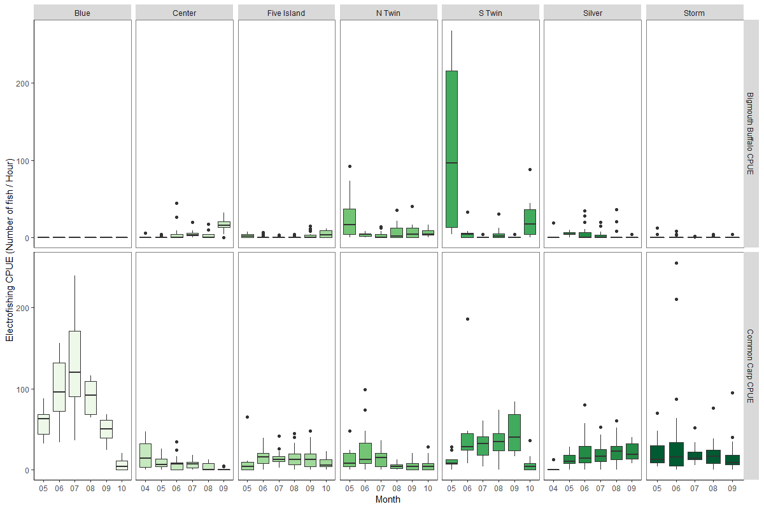

**Figure 4**. Mean catch-per-unit-effort (# fish/hour) in each month for bigmouth buffalo (top panels) and common carp (bottom panels) from all electrofishing transects at seven lakes sampled in 2019.

In 2017, age structures were collected from Blue, Center, and North and South Twin Lakes. In 2018, dorsal spines were collected in all lakes for both species, and otoliths were collected in Five Island, Silver, and Storm Lakes. Fish ages in both years were estimated in the lab after structures were sectioned and mounted on microscope slides. Dorsal spines were collected from up to 150 fish of both species in each lake during 2019. Laboratory processing and analysis of 2019 age structures are ongoing in 2020.

Age estimates from dorsal spines of both species were used to develop relationships between fish age and length. These relationships are often nonlinear as the increments of fish growth per year decrease as fish get older. Raw data of fish size and an assignment of age is most commonly applied to model fish growth using a modified von Bertalanffy growth model (VBGM; Beverton and Holt 1957, Cailliet et al. 2006). This model is represented by the nonlinear equation

$$E[L|t]=L_{∞}* (1-e^{-K\left(t-t_{0}\right)})$$

where *E[L|t]* is the expected (or average) length at age t, $L_{∞}$ is the asymptotic average maximum length, *K* is the growth rate coefficient (yr-1 ), and *t0* is a theoretical value to represent the time or age when average length was 0. Confidence intervals for fitted growth curve models were estimated from boostrapping the data. Results from VGBM models indicate that both common carp and bigmouth buffalo have different growth rates and maximum lengths among lakes (Table 3, Figure 8 and Figure 9). The paucity of young individuals (age < 3) for both common carp and bigmouth buffalo has resulted in poor estimation of juvenile growth rates in the VBGM framework. Therefore, length at *t0* was fixed at zero to improve model estimates. Ages for bigmouth buffalo in South Twin Lake were particularly problematic, and growth models did not converge for age-length relationships for bigmouth buffalo in South Twin Lake for both 2017 and 2018. Additionally, growth models for bigmouth buffalo in Storm Lake did not converge from age structures collected in 2018. In the case of both species in all lakes, some age estimates appear to be incorrect when compared to the lengths of other fish estimated to be the 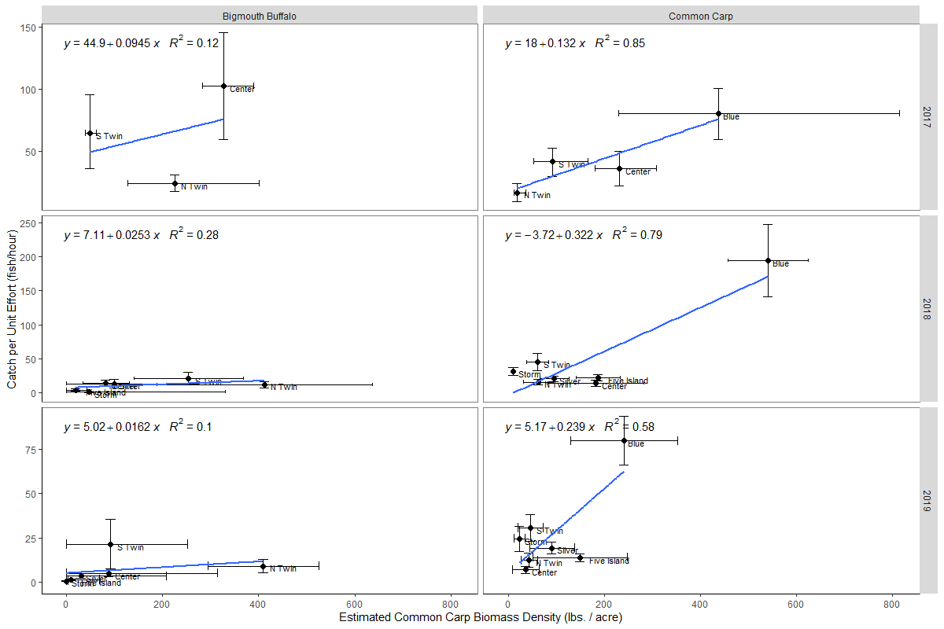same age; therefore, re-aging of fish structures and quality control is ongoing in 2020.

**Figure 5**. Relationship between estimated biomass density (pounds per acre) and overall electrofishing catch-per-unit-effort (fish/hour) for bigmouth buffalo (left) and common carp (right) from 2017 to 2019 (top to bottom). Error bars represent 95% confidence intervals.

Age frequency histograms were developed for both species from age structures collected in 2017 and 2018 (Figure 10). Dorsal spines were used to estimate fish age for both species in both years. Age distribution indicates generally consistent recruitment among lakes but that recruitment varies among lakes and species. Although the scarcity of common carp and bigmouth buffalo less than five years old in Center Lake indicates that physical barriers to spawning habitat may have reduced annual recruitment, those age classes are rare in all sample lakes.

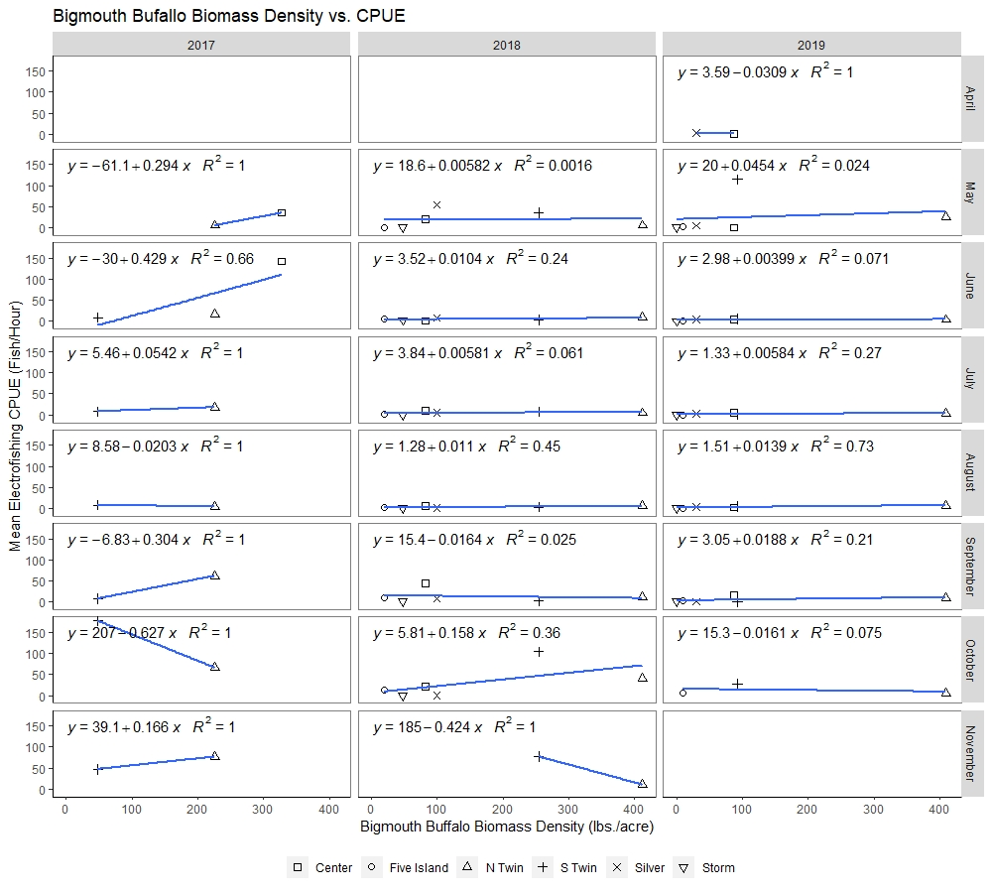

**Figure 6**. Relationship between monthly mean bigmouth buffalo catch-per-unit-effort (# fish/hour) and annual biomass density (lbs. per acre) across all seven study lakes. Mean CPUE estimates in each month (rows, top to bottom) come from all electrofishing transects in each sampling season between 2017 and 2019 (columns, left to right).

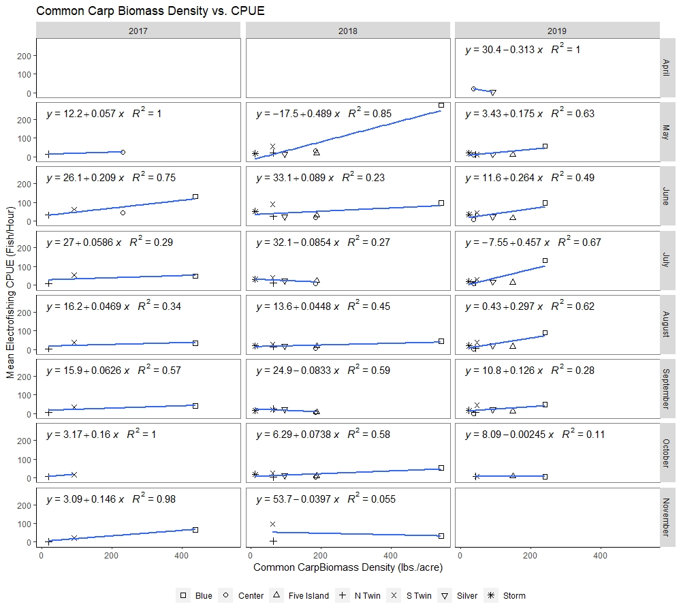

**Figure 7**. Relationship between monthly mean common carp catch-per-unit-effort (# fish/hour) and annual biomass density (lbs. per acre) across all seven study lakes. Mean CPUE estimates in each month (rows, top to bottom) come from all electrofishing transects in each sampling season between 2017 and 2019 (columns, left to right).

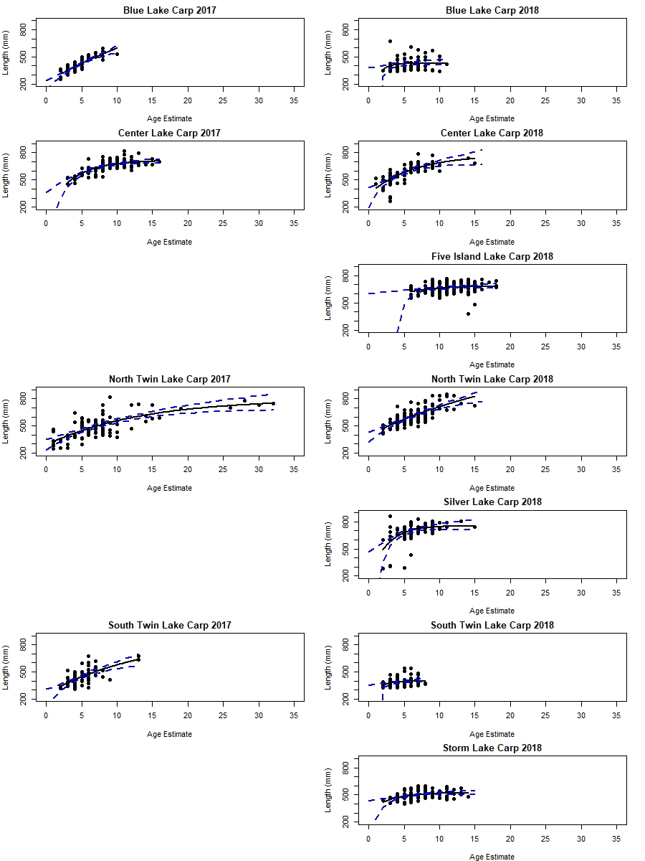

**Figure 8.** Relationship between common carp age (years, x-axis) and total length (mm, y-axis). Ages were estimated from dorsal spines collected in 2017 and 2018. Preliminary growth curves (solid line = fitted mean, dotted line = 95% CI) calculated by nonlinear least squares regression. No common carp age structures were collected in Five Island, Silver, or Storm lakes in 2017.

|  |  |  |  |  |  |  |  |  |  |  |  |  |
| --- | --- | --- | --- | --- | --- | --- | --- | --- | --- | --- | --- | --- |
| Table 3. Estimates of $L_{∞}$ (asymptotic maximum length (mm)), *K* (growth rate coefficient (yr-1)), and *t0* (theoretical length at time zero (mm)) for common carp (COC) and bigmouth buffalo (BIB) in 2017 and 2018. Note that fitting a non-linear model to estimates for bigmouth buffalo in South Twin Lake did not converge in either year, and Storm Lake bigmouth buffalo data was insufficient to fit a non-linear growth model (marked with *). | | | | | | | | | | | | |
| Lake | *L∞* (mm) | | *K* | | *t0* | | | | | | |
|  | COC | BIB | COC | BIB | | COC | | | BIB | |
| Blue Lake  2017  2018 | 530  427 | N/A  N/A | 0.1509  1.4286 | N/A  N/A | | | -4.126  0.785 | N/A  N/A | |
| Center Lake  2017  2018 | 704  676 | 699  585 | 0.2795  0.2442 | 0.0563  0.2933 | | | -1.243  -4.221 | -13.11  -3.298 | |
| Five Island Lake  2017  2018 | N/A  680 | N/A  675 | N/A  0.6044 | N/A  0.4223 | | | N/A  1.869 | N/A  -0.446 | |
| North Twin Lake  2017  2018 | 675  778 | 633  737 | 0.2016  0.1714 | 0.2388  0.2089 | | | -2.387  -3.410 | -2.888  -6.293 | |
| Silver Lake  2017  2018 | N/A  746 | N/A  888 | N/A  0.6944 | N/A  0.1702 | | | N/A  0.715 | N/A  -1.569 | |
| South Twin Lake  2017  2018 | 495  390 | 579*  -165* | 1.1451  1.2754 | 0.3066*  -0.0214* | | | 1.061  0.147 | -1.296*  -53.88* | |
| Storm Lake  2017  2018 | N/A  502* | N/A  N/A | N/A  0.5400* | N/A  N/A | | | N/A  -1.839* | N/A  N/A | |

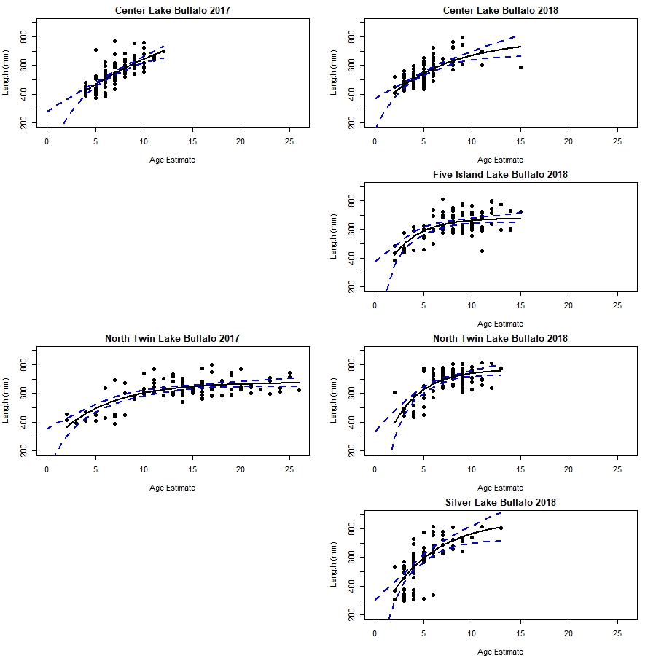

**Figure 9.** Relationship between bigmouth buffalo age (years, x-axis) and total length (mm, y-axis). Ages were estimated from dorsal spines collected in 2017 and 2018. Preliminary growth curves (solid line = fitted mean, dotted line = 95% CI) calculated by nonlinear least squares regression. No bigmouth buffalo age structures were collected in Five Island, Silver, or Storm lakes in 2017. Growth models for bigmouth buffalo did not converge in South Twin Lake for either sample year; data was insufficient for Storm Lake growth curve analysis for 2018 samples.

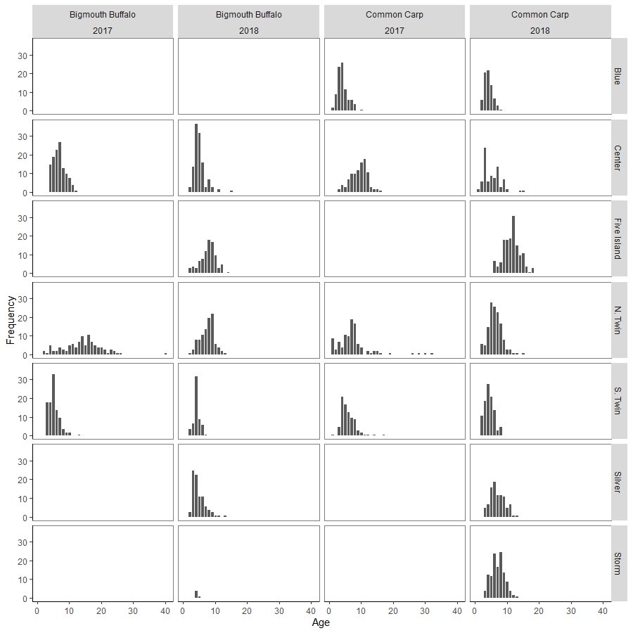

**Figure 10.** Age-frequency histograms of bigmouth buffalo (left two columns) and common carp (right two columns) estimated from sectioned dorsal fin spines collected 2017 and 2018.

**Task 2: Carp/Buffalo Removal Monitoring**

Each study lake has a unique history of commercial harvest, where common carp and bigmouth buffalo populations may be harvested once, multiple times, or not at all in a given year. Additionally, harvest contracts impose limits on the time of year when water temperatures are lower to try and reduce stress on fish and minimize bycatch mortality. It is therefore appropriate to group harvest events by seasons spanning the Gregorian New Year. For example, harvest that occurs between fall 2015 and spring 2016 are grouped into a “15-16” harvest period.

The first opportunity for tagged fish to be harvested occurred between fall 2017 and spring 2018. An unusually long winter led to a shortened spring harvest season, but harvest occurred in Center Lake and Five Island Lake before ISU and Iowa DNR sampling began in May 2018. Harvest also occurred in fall 2018 in Silver Lake and Five Island Lake. An incentivized harvest program was implemented for common carp in Center Lake in 2019 and for bigmouth buffalo in North Twin Lake in 2019. Common carp and bigmouth buffalo harvest, in total biomass (pounds) and standardized removal (pounds removed per acre), are summarized for each lake in Figure 11. Commercial harvest after December 2019 is not yet included in this data.

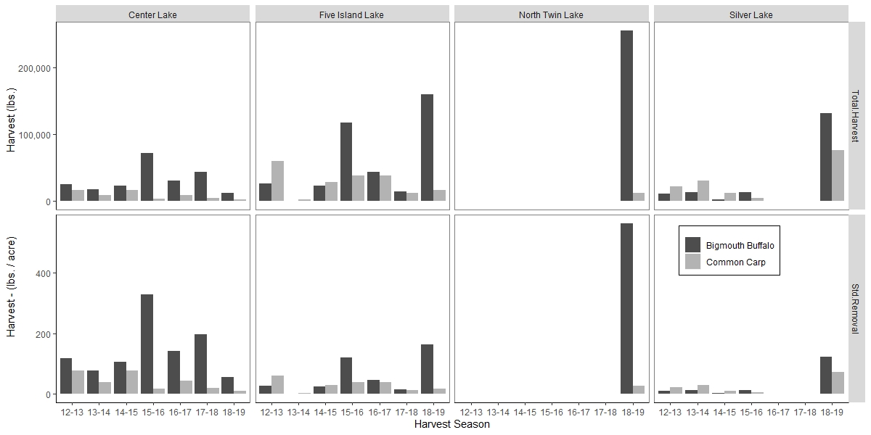

**Figure 11**. Commercial harvest of common carp and bigmouth buffalo reported in total pounds (top panel) and as standardized removal (lbs. per acre; bottom panel) between fall 2012 and fall 2019. Harvest after December 2019 is not yet included in this data.

Commercial anglers agreed to notify the Iowa DNR of their harvest events for participation in tag collection from marked fish. This proved difficult to coordinate, as tags were only returned from fish harvested from Silver Lake in October 2018 and not from spring harvests. Therefore, all future commercial fishing contracts for common carp and bigmouth buffalo in 2019 and beyond will stipulate that all tags from marked fish must be removed and returned to Iowa DNR and Iowa State University for subsequent estimation of harvest mortality, and that personnel designated by ISU or Iowa DNR may be present to inspect harvested fish for tags and tag loss. This change to the contract language worked well, as either ISU or Iowa DNR attended nearly all haul events to monitor the retrieval of tags from harvested fish.

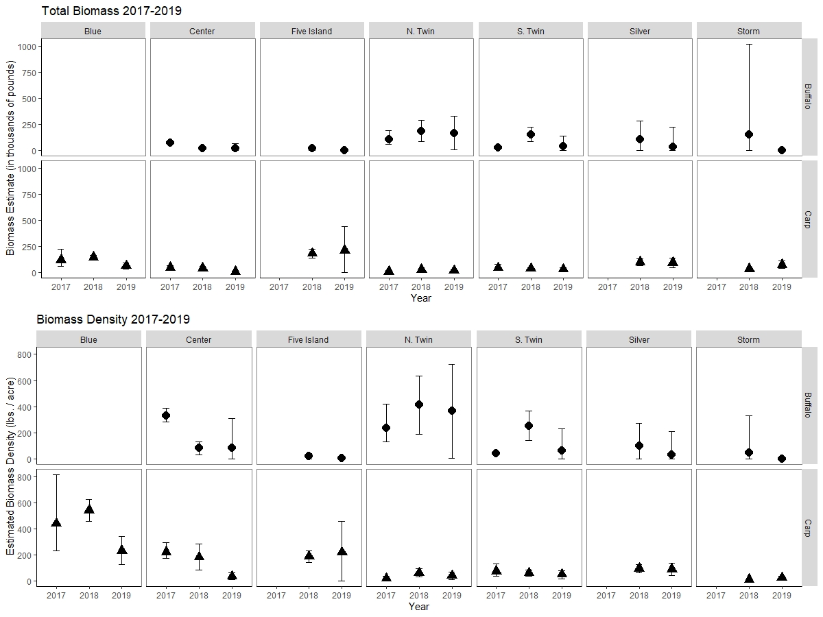

**Figure 12:** Bigmouth buffalo and common carp estimates of total biomass (top; thousands of lbs.) and biomass density (bottom; lbs./acre) between 2017 and 2019. Note that no fish were tagged in Five Island, Silver, and Storm lakes in 2017.

Estimates of exploitation due to commercial harvest are ongoing in 2020 and will continue through the end of the project. Of the four lakes where common carp and bigmouth buffalo were tagged in 2017, only one (Center Lake) experienced harvest in 2018. Tagged fish were also harvested in 2018-2019 in Silver Lake, Center Lake, North Twin Lake, and Five Island Lake. As of January 2020, capture-mark-recapture data is insufficient for accurate and meaningful survival estimates. Therefore, the most appropriate comparisons that can currently be made are evaluations of year-to-year changes in estimates of biomass and biomass density between non-harvested lakes (Blue Lake, South Twin Lake, and Storm Lake) and lakes with harvest (Center Lake, Silver Lake, North Twin Lake, and Five Island Lake, Figure 12).

Changes in bigmouth buffalo biomass in Center Lake tracked closely with biomass removal between 2017 and 2018. During that time, a total of 43,500 lbs. of bigmouth buffalo were removed from Center Lake, and the biomass estimates were significantly lower in 2018 than 2017. Changes in biomass density for bigmouth buffalo followed a similar pattern, where 198 lbs./acre were removed between sampling seasons and the estimates of bigmouth buffalo biomass density were about 200 lbs./acre less in 2018 compared to 2017. However, biomass estimates of bigmouth buffalo in Center Lake did not change significantly between 2018 and 2019 (despite harvest).

Changes in common carp estimates also followed a pattern similar to Center Lake, where 4,500 lbs. were removed between the 2017 and 2018 sampling seasons. Although neither the estimated biomass nor biomass density saw a significant reduction after harvest, the estimates for both metrics decreased. In 2019, an incentivized harvest contract was implemented in Center Lake, but the quotas were not met by the commercial angler. Despite very little harvest, common carp biomass and biomass density decreased between 2018 and 2019.

In North Twin Lake, an incentivized harvest contract was implemented for bigmouth buffalo in the 2019 calendar year. The commercial anglers exceeded their quota of 120,000 lbs. of bigmouth buffalo (Figure 11) and were given a contract extension to continue harvest through May 2020. Despite significant harvest of bigmouth buffalo in early 2019, the 2019 bigmouth buffalo biomass estimates remained similar to 2018, and common carp biomass remained consistent across study years (Figure 12).

Although harvest occurred in 2018-2019 in Five Island Lake, biomass estimates of both common carp and bigmouth buffalo were consistent between years. Similarly, harvest in Silver Lake in late 2018 appeared to have no significant effect on bigmouth buffalo or common carp biomass estimates, although the point estimate for bigmouth buffalo biomass did decrease. Data from Blue Lake show a decrease in carp biomass estimates between 2018 and 2019, but confidence intervals for all years overlap. Other biomass estimates for common carp and bigmouth buffalo in South Twin Lake and Storm Lake have remained fairly consistent across study years.

Due to the failure of commercial anglers to meet the quota in Center Lake, no commercial fishing contract was renewed for that lake in 2020. The no-cost extension of the North Twin Lake commercial fishing contract to May 2020 means that there will be no common carp or bigmouth buffalo harvest in North Twin during fall 2020, although abundance and biomass estimates derived from summer 2020 data may inform whether or not a new contract may be awarded for calendar year 2021 in North Twin Lake. Silver Lake, Storm Lake, and Five Island Lake all have traditional commercial fishing contracts for 2020.

**Task 3: Fish Community Surveys**

Two types of fish community surveys were implemented in each of the seven study lakes in 2018 and 2019. In the spring, all fishes were collected by pulsed DC boat electrofishing according to Iowa DNR standard protocol for comprehensive surveys. Sampling occurred during the day between May 1 and June 30 of each year when water temperatures were between 60°F and 75°F. Each electrofishing run was 15 minutes (900 seconds) in duration at multiple fixed locations in the lake; the number of stations sampled varied based on lake size (Appendices A-G).

Fishes were sampled again in the fall of both years using fyke nets that conform to the current Iowa DNR protocol in that sampling occurred between mid-August and mid-October when water temperatures were between 60°F and 75°F. Net frames were 2’ x 4’ with seven 2’ diameter hoops and two net throats along cod end of net. Nets had a ¾” bar mesh size and 40’ lead end toward the shoreline. Fyke nets were deployed once overnight at fixed Iowa DNR survey points along the shoreline of each study lake. The number of stations per lake varied between 5 and 12, depending on lake size. Unfortunately, weather constraints and logistics prevented fyke nets from being set in Five Island Lake in 2019. Length was recorded for each fish collected. In addition, age structures were collected from a subset of common and recreationally important sportfish (e.g., bluegill, crappie, bass). Up to five individuals per half-inch length category were weighed and euthanized and dissected for extraction of otoliths. Laboratory work to process otoliths and age fish are ongoing tasks in 2020.

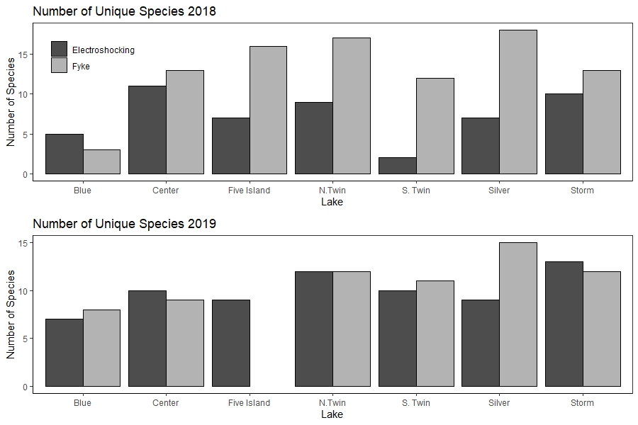

**Figure 13.** Total number of fishes sampled in seven lakes in NW Iowa. Samples were collected using spring boat electrofishing and fall fyke netting (Iowa DNR standardized community survey methods).

In total, 26 different species of fish and three species of turtles were sampled in 2018. The count of unique species sampled in both gears in each lake showed that the fall fyke nets yielded more fishes than spring boat electrofishing, with the exception of Blue Lake (Figure 13). In 2019, 30 different fishes and one species of turtle were sampled. Each gear captured similar numbers of species in 2019, except in Silver Lake where fyke nets captured more species than boat electrofishing.

In order to describe the fish community structure at each study lake, length frequency data was summarized into Proportional Size Distributions (PSDx). A PSDx index is defined for each PSD category (substock, stock, quality, preferred, memorable, trophy) and is reported as the proportion of stock-sized fish in that category and any larger size category. The length categories are determined for a wide variety of species (Gabelhouse 1984); stock-sized fish are at least 20% of the world record length, quality sized fish are at least 36% of world record length, and so on. Each larger size category is a subset of the previous category. The formula for PSDx is given as

$${PSD}_{x}= \frac{\# fish ≥specified length}{\# fish ≥stock length}*100$$

where the *x* in this formula is replaced with a letter specific to the length required by the numerator. For example, PSDQ would have a numerator that is the number of fish greater than or equal to “quality” size and is interpreted as the proportion of all fish in that species of stock size or greater that are also quality-sized or greater.

Fishes captured in the comprehensive fyke net surveys are presented in Table 4; fishes captured in the comprehensive electrofishing surveys are presented in Table 5. The number of fish in each size category are reported first, with the PSDx proportion in parentheses. PSDx values are a percentage but will be reported as an integer proportion (out of 100) and shown without a percentage sign. Not all species collected in 2019 have defined PSDx categories (e.g., spotfin shiner). When PSDx categories were unavailable, only the total number of individuals is reported. PSD values from electrofishing and fyke net surveys in completed in 2018 are retained in Appendix H.

|  |  |  |  |  |  |  |  |  |  |  |  |  |  |
| --- | --- | --- | --- | --- | --- | --- | --- | --- | --- | --- | --- | --- | --- |
| Table 4. Number of fish in each Proportional Size Distribution (PSDX) category for fishes sampled in comprehensive fyke net surveys from six lakes in NW Iowa in 2019. Number of fish captured in each category is reported first, followed by the proportion of fish in each PSDx category – out of all fish stock size or larger – in parentheses. PSDX lengths are from Gablehouse (1984). | | | | | | | | | | | | | |
|  | Substock | Stock | Quality (PSD) | Preferred (PSD-P) | | Memorable  (PSD-M) | Trophy  (PSD-T) | | | Total in all samples | |  | |
| Blue Lake  Black Crappie  Bluegill  Channel Catfish  Common Carp  Green Sunfish  Largemouth Bass  Madtom | 89  24  1  0  0  2  - | 85  184  2  1  2  0  - | 26 (25)  72 (28)  1 (33)  1 (50)  0 (0)  0 (100)  - | 2 (2)  1 (0)  0 (0)  0 (0)  0 (0)  0 (100)  - | 0 (0)  0 (0)  0 (0)  0 (0)  0 (0)  1 (100)  - | | | 0 (0)  0 (0)  0 (0)  0 (0)  0 (0)  0 (0)  - | 202  281  4  2  2  2  3  1 | |  | |
| Center Lake  Black Crappie  Bluegill  Largemouth Bass  Painted Turtle  Pumpkinseed  Walleye  White Crappie  Yellow Bass  Yellow Bullhead | 4  1  20  -  1  1  0  1  0 | 10  12  0  -  0  3  1  0  0 | 3 (77)  32(73)  0 (0)  -  0 (0)  2 (40)  0 (50)  3 (100)  2 (100) | 31 (71)  1 (2)  0 (0)  -  0 (0)  0 (0)  1 (50)  2 (40)  9 (88) | 0 (0)  0 (0)  0 (0)  -  0 (0)  0 (0)  0 (0)  0 (0)  6 (35) | | | 0 (0)  0 (0)  0 (0)  -  0 (0)  0 (0)  0 (0)  0 (0)  0 (0) | 48  46  20  1  1  6  2  5  17 | |  | |
| North Twin Lake  Black Bullhead  Bluegill  Freshwater Drum  Green Sunfish  Hybrid Sunfish  Painted Turtle  Spotfin Shiner  Walleye  White Crappie  Yellow Bass  Yellow Bullhead  Yellow Perch | 312  1  0  0  -  -  -  4  3  0  0  0 | 2  21  0  0  -  -  -  7  158  3  3  1 | 0 (50)  38 (66)  0 (100)  1 (100)  -  -  -  1 (46)  64 (30)  5 (90)  13 (89)  1 (50) | 2 (50)  2 (3)  2 (100)  0 (0)  -  -  -  5 (39)  4 (2)  22 (73)  9 (41)  0 (0) | 0 (0)  0 (0)  0 (0)  0 (0)  -  -  -  1 (7)  0 (0)  0 (0)  2 (7)  0 (0) | | | 0 (0)  0 (0)  0 (0)  0 (0)  -  -  -  0 (0)  0 (0)  0 (0)  0 (0)  0 (0) | 316  62  2  1  1  1  2  17  229  30  27  2 | |  | |
| Silver Lake (Dickinson)  Bigmouth Buffalo  Black Crappie  Bluegill  Freshwater Drum  Green Sunfish  Largemouth Bass  Northern Pike  Painted turtle  Pumpkinseed  Spottail Shiner  Walleye  White Sucker  Yellow Bass  Yellow Bullhead  Yellow Perch | 2  13  14  619  0  3  1  -  0  -  12  0  5  0  11 | 0  0  23  0  1  1  1  -  0  -  22  0  218  0  4 | 0 (0)  1 (100)  7 (41)  0 (0)  0 (0)  0 (50)  2 (75)  -  1 (100)  -  7 (31)  2 (100)  14 (27)  0 (100)  0 (0) | 0 (0)  2 (67)  9 (23)  0 (0)  0 (0)  1 (50)  1 (25)  -  0 (0)  -  3 (9)  1 (67)  64 (22)  1 (100)  0 (0) | 0 (0)  0 (0)  0 (0)  0 (0)  0 (0)  0 (0)  0 (0)  -  0 (0)  -  0 (0)  2 (50)  3 (1)  0 (0)  0 (0) | | | 0 (0)  0 (0)  0 (0)  0 (0)  0 (0)  0 (0)  0 (0)  -  0 (0)  -  0 (0)  1 (17)  0 (0)  0 (0)  0 (0) | 2  16  53  619  1  5  5  2  1  4  157  6  304  1  15 | |  | |
| South Twin Lake  Black Bullhead  Bluegill  Common Carp  Freshwater Drum  Northern Pike  Orangespotted Sunfish  Painted Turtle  White Crappie  Yellow Bass  Yellow Bullhead  Yellow Perch | 273  0  6  17  0  -  -  101  0  0  0 | 31  5  3  22  0  -  -  206  4  31  4 | 2 (6)  0 (0)  3 (50)  0 (0)  0 (100)  -  -  9 (4)  0 (0)  11 (39)  0 (0) | 0 (0)  0 (0)  0 (0)  0 (0)  1 (100)  -  -  0 (0)  0 (0)  9 (18)  0 (0) | 0 (0)  0 (0)  0 (0)  0 (0)  0 (0)  -  -  0 (0)  0 (0)  0 (0)  0 (0) | | | 0 (0)  0 (0)  0 (0)  0 (0)  0 (0)  -  -  0 (0)  0 (0)  0 (0)  0 (0) | 306  5  12  39  1  11  6  316  4  51  4 | |  | |
| Storm Lake  Black Crappie  Bluegill  Channel Catfish  Emerald Shiner  Gizzard Shad  Largemouth Bass  Spottail Shiner  Walleye  White Bass  White Crappie  Yellow Perch | 10  8  2  -  4,682  8  -  99  693  231  11 | 0  9  0  -  0  4  -  11  455  1  1 | 0 (0)  1 (10)  0 (100)  -  1 (100)  0 (0)  -  0 (0)  1 (0)  32 (97) 1 (50) | 0 (0)  0 (0)  1 (100)  -  0 (0)  0 (0)  -  0 (0)  0 (0)  1 (3)  0 (0) | 0 (0)  0 (0)  0 (0)  -  0 (0)  0 (0)  -  0 (0)  0 (0)  0 (0)  0 (0) | | | 0 (0)  0 (0)  0 (0)  -  0 (0)  0 (0)  -  0 (0)  0 (0)  0 (0)  0 (0) | 10  18  3  3  4,683  12  71  110  1,149  265  13 | |  | |

|  |  |  |  |  |  |  |  |  |  |  |  |  |  |
| --- | --- | --- | --- | --- | --- | --- | --- | --- | --- | --- | --- | --- | --- |
| Table 5. Number of fish in each Proportional Size Distribution (PSDX) category for fishes sampled in comprehensive electrofishing surveys from seven lakes in NW Iowa in 2019. Number of fish captured in each category is reported first, followed by the proportion of fish in each PSDx category – out of all fish stock size or larger – in parentheses. PSDX lengths are from Gablehouse (1984). | | | | | | | | | | | | | |
|  | Substock | Stock | Quality (PSD) | Preferred (PSD-P) | | Memorable  (PSD-M) | Trophy  (PSD-T) | | | Total in all samples | |  | |
| Blue Lake  Black Crappie  Bluegill  Channel Catfish  Common Carp  Green Sunfish  Largemouth Bass | 0  15  0  0  0  31 | 0  25  0  37  1  0 | 1 (100)  22 (47)  1 (100)  20 (50)  0 (0)  1 (100) | 0 (0)  0 (0)  0 (0)  4 (7)  0 (0)  12 (93) | 0 (0)  0 (0)  0 (0)  0 (0)  0 (0)  1 (7) | | | 0 (0)  0 (0)  0 (0)  0 (0)  0 (0)  0 (0) | 1  62  1  61  1  45 | |  | |
| Center Lake  Bigmouth Buffalo  Black Crappie  Bluegill  Brown Bullhead  Common Carp  Freshwater Drum  Largemouth Bass  Walleye  Yellow Bass | 0  0  0  0  0  0  0  0  0 | 1  0  3  0  0  0  0  3  1 | 19 (95)  2 (100)  20 (89)  0 (100)  2 (100)  0 (100)  4 (100)  0 (0)  2 (75) | 1 (5)  2 (50)  4 (15)  4 (100)  12 (88)  1 (100)  0 (0)  0 (0)  1 (25) | 0 (0)  0 (0)  0 (0)  0 (0)  3 (18)  0 (0)  0 (0)  0 (0)  0 (0) | | | 0 (0)  0 (0)  0 (0)  0 (0)  0 (0)  0 (0)  0 (0)  0 (0)  0 (0) | 21  4  27  4  17  1  4  3  4 | |  | |
| Five Island Lake  Bigmouth Buffalo  Bluegill  Channel Catfish  Common Carp  Largemouth Bass  Walleye  Yellow Bass  Yellow Perch | 0  0  1  0  0  0  0  0 | 0  1  4  0  3  1  31  4 | 0 (100)  3 (80)  12 (75)  0 (100)  10 (79)  1 (67)  20 (39)  0 (0) | 1 (100)  1 (20)  0 (0)  23 (100)  1 (7)  1 (33)  0 (0)  0 (0) | 0 (0)  0 (0)  0 (0)  7 (23)  0 (0)  0 (0)  0 (0)  0 (0) | | | 0 (0)  0 (0)  0 (0)  0 (0)  0 (0)  0 (0)  0 (0)  0 (0) | 1  5  17  30  14  3  51  5 | |  | |
| North Twin Lake  Bigmouth Buffalo  Bluegill  Channel Catfish  Common Carp  Freshwater Drum  Walleye  White Bass  White Crappie  Yellow Bass  Yellow Perch | 0  0  0  0  0  1  1  0  243  1 | 2  9  0  0  0  0  0  0  28  0 | 12 (91)  6 (40)  5 (100)  4 (100)  11 (100)  0 (100)  0 (0)  1 (100)  17 (42)  0 (0) | 7 (36)  0 (0)  0 (0)  32 (91)  9 (45)  1 (100)  0 (0)  2 (67)  3 (6)  0 (0) | 1 (5)  0 (0)  0 (0)  10 (22)  0 (0)  1 (50)  0 (0)  0 (0)  0 (0)  0 (0) | | | 0 (0)  0 (0)  0 (0)  0 (0)  0 (0)  0 (0)  0 (0)  0 (0)  0 (0)  0 (0) | 22  15  5  46  20  3  1  13  291  1 | |  | |
| Silver Lake (Dickinson)  Bigmouth Buffalo  Common Carp  Largemouth Bass  Northern Pike  Walleye  White Bass  Yellow Bass  Yellow Perch | 0  1  0  1  0  0  0  0 | 3  0  0  0  4  0  0  0 | 8 (81)  3 (100)  1 (100)  1 (100)  15 (81)  2 (100)  30 (100)  0 (100) | 4 (31)  3 (92)  1 (50)  0 (0)  2 (10)  3 (67)  15 (35)  1 (100) | 1 (6)  29 (83)  0 (0)  0 (0)  0 (0)  1 (17)  1 (2)  0 (0) | | | 0 (0)  1 (3)  0 (0)  0 (0)  0 (0)  0 (0)  0 (0)  0 (0) | 16  37  2  2  21  6  46  1 | |  | |
| South Twin Lake  Bigmouth Buffalo  Black Bullhead  Brown Bullhead  Common Carp  Freshwater Drum  Walleye  White Crappie  Yellow Bass  Yellow Perch | 0  1  0  5  0  3  0  1  1 | 57  34  7  12  0  0  0  25  0 | 167 (75)  0 (0)  4 (36)  5 (29)  1 (100)  0 (100)  3 (100)  0 (0)  0 (0) | 7 (3)  0 (0)  0 (0)  0 (0)  0 (0)  1 (100)  0 (0)  0 (0)  0 (0) | 0 (0)  0 (0)  0 (0)  0 (0)  0 (0)  0 (0)  0 (0)  0 (0)  0 (0) | | | 0 (0)  0 (0)  0 (0)  0 (0)  0 (0)  0 (0)  0 (0)  0 (0)  0 (0) | 231  35  11  22  1  4  3  26  1 | |  | |
| Storm Lake  Bigmouth Buffalo  Bluegill  Channel Catfish  Common Carp  Gizzard Shad  Smallmouth Bass  Walleye  White Bass  White Sucker  Yellow Perch | 0  0  0  0  0  0  0  0  0  2 | 0  0  0  2  0  1  0  0  0  0 | 3 (100)  0 (100)  3 (100)  6 (91)  31 (100)  0 (0)  2 (100)  0 (100)  0 (100)  0 (0) | 0 (0)  1 (100)  0 (0)  15 (65)  0 (0)  0 (0)  1 (60)  56 (100)  0 (100)  0 (0) | 0 (0)  0 (0)  0 (0)  0 (0)  0 (0)  0 (0)  2 (40)  4 (7)  1 (100)  0 (0) | | | 0 (0)  0 (0)  0 (0)  0 (0)  0 (0)  0 (0)  0 (0)  0 (0)  0 (0)  0 (0) | 3  1  3  23  31  1  5  60  1  2 | |  | |

**Discussion and Conclusion**

Coordination with commercial fishing contractors has improved in 2019. Commercial fishers that have been awarded incentivized and traditional commercial fishing contracts have been in frequent contact with Iowa DNR and ISU personnel to allow observation of harvest and arrange return of tags from harvested fish. Cooperation between commercial fishing outfits and ISU/Iowa DNR personnel in 2018 resulted in large-scale tagging events that assisted with reducing variability in data and improving estimates. However, the same tagging assistance was only executed successfully in North Twin Lake in 2019. Another unsuccessful attempt to seine fish for tagging occurred in Five Island Lake, but a storm dislodged the net and only about 45 fish remained in the net pen to be tagged. Commercial anglers chose not to seine fish in Storm Lake and receive a per-pound payment for tagged fish in 2019.

In general, public reaction to this research has been positive. There has been frequent interaction with anglers and other people using these lakes recreationally, and for the most part everyone is in favor of this lake restoration program and improving fisheries. Social media posts are also common, and usually positive. Coordination between ISU and Iowa DNR has resulted in efficient execution of study design, and the exchange of labor and resources has been a benefit to this research.

**Literature cited:**

Bajer, P.G., and P.W. Sorensen. 2012. Using boat electrofishing to estimate the abundance of invasive Common Carp in small Midwestern lakes. North American Journal of Fisheries Management 32:817-822.

Beverton R. J. H., Holt SJ (1957). On the dynamics of exploited fish populations. United Kingdom Ministry of Agriculture and Fisheries, Fisheries Investigations (Series 2) 19, 533 pp

Brown, P., and T. I. Walker. 2004. CARPSIM: stochastic simulation modelling of wild carp (*Cyprinus carpio* L.) population dynamics, with applications to pest control. Ecological Modelling 176:83-97.

Cailliet, G. M., et al. 2006. Age and growth studies of chondrichthyan fishes: the need for consistency in terminology, verification, validation, and growth function fitting. Environmental Biology of Fishes 77: 211-228.

Carpenter, S. R., and J. F. Kitchell. 1988. Consumer control of lake productivity. BioScience 38:764-769.

Carpenter, S. R., J. F. Kitchell, and J. R. Hodgson. 1985. Cascading trophic interactions and lake productivity. BioScience 35:634-639.

Colvin, M. E., C. L. Pierce, and T. W. Stewart. 2012. Semidiscrete biomass dynamic modeling: an improved approach for assessing fish stock responses to pulsed harvest events. Canadian Journal of Fisheries and Aquatic Sciences 69:1710-1721.

Gablehouse, J., D. W. 1984. A length-categorization system to assess fish stocks. North American Journal of Fisheries Management 4:2743-285.

Hein, C. L., B. M. Roth, A. R. Ives, and M. J. Vander Zanden. 2006. Fish predation and trapping for rusty crayfish (*Orconectes rusticus*) control: a whole-lake experiment. Canadian Journal of Fisheries & Aquatic Sciences 63:383-393.

Jackson, Z. J., M. C. Quist, J. A. Downing, and J. G. Larscheid. 2010. Common carp (*Cyprinus carpio*), sport fishes, and water quality: Ecological thresholds in agriculturally eutrophic lakes. Lake and Reservoir Management 26:14-22.

Koehn, J. D. 2004. Carp (*Cyprinus carpio*) as a powerful invader in Australian waterways. Freshwater Biology 49:882-894.

McComish, T.S. 1967. Food habits of Bigmouth and Smallmouth Buffalo in Lewis and Clark Lake and Missouri River. Transactions of the American Fisheries Society 96:70-74

Meronek, T. G., P. M. Bouchard, E. R. Buckner, T. M. Burri, K. K. Demmerly, D. C. Hatleli, R. A. Klumb, S. H. Schmidt, and D. W. Coble. 1996. A review of fish control projects. North American Journal of Fisheries Management 16:63-74.

Ricker, W.E. 1975. Computation and interpretation of biological statistics of fish populations. Bull. Fish. Res. Board Can 191:382.

Scheffer, M., S. Carpenter, J. A. Foley, C. Folke, and B. Walker. 2001. Catastrophic shifts in ecosystems. Nature 413:591-596.

Weber, M. J., and M. L. Brown. 2009. Effects of common carp on aquatic ecosystems 80 years after 'Carp as a dominant': Ecological insights for fisheries management. Reviews in Fisheries Science 17:524-537.

Weber, M. J., and M. L. Brown. 2011. Relationships among invasive common carp, native fishes and physicochemical characteristics in upper Midwest (USA) lakes. Ecology of Freshwater Fish 20:270-278.

Zipkin, E. F., P. J. Sullivan, E. G. Cooch, C. E. Kraft, B. J. Shuter, and B. C. Weidel. 2008. Overcompensatory response of a smallmouth bass (*Micropterus dolomieu*) population to harvest: release from competition? Canadian Journal of Fisheries and Aquatic Sciences 65:2279-2292.

Appendix A. Blue Lake, Iowa. Electrofishing transects are run between yellow pins; fyke net locations are marked by red pins.

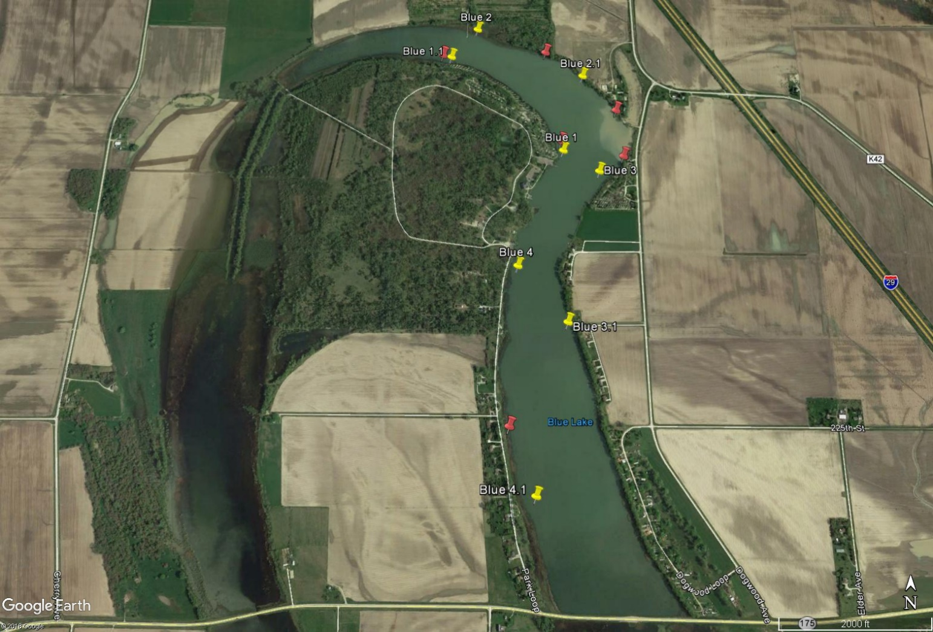

Appendix B. Center Lake, Iowa. Electrofishing transects are run between yellow pins; fyke net locations are marked by red pins.

Appendix C. Five Island Lake, Iowa. Electrofishing transects are run between yellow pins; fyke net locations are marked by red pins.

Appendix D. North Twin Lake, Iowa. Electrofishing transects are run between yellow pins; fyke net locations are marked by red pins.

Appendix E. Silver Lake (Dickinson County), Iowa. Electrofishing transects are run between yellow pins; fyke net locations are marked by red pins.

Appendix F. South Twin Lake, Iowa. Electrofishing transects are run between yellow pins; fyke net locations are marked by red pins.

Appendix G. Storm Lake, Iowa. Electrofishing transects are run between yellow pins; fyke net locations are marked by red pins.

|  |  |  |  |  |  |  |  |  |  |  |  |  |  |
| --- | --- | --- | --- | --- | --- | --- | --- | --- | --- | --- | --- | --- | --- |
| Appendix H. Number of fish in each Proportional Size Distribution (PSDX) category for fishes sampled via fyke nets from seven lakes in NW Iowa in 2018. Number of fish in each category is followed by the proportion (in parentheses) of all fish in each PSDX category out of all fish sampled that were stock size or larger. PSDX lengths are from Gablehouse (1984). | | | | | | | | | | | | | |
|  | Substock | Stock | Quality (PSD) | Preferred (PSD-P) | | Memorable  (PSD-M) | Trophy  (PSD-T) | | | Total in all samples | |  | |
| Blue Lake  Black Crappie  Bluegill  Largemouth Bass | 10  11  0 | 11  8  0 | 6 (39)  6 (43)  1 (100) | 0 (6)  0 (0)  (0) | 1 (6)  0 (0)  0 (0) | | | 0 (0)  0 (0)  0 (0) | 28  25  1 | |  | |
| Center Lake  Bigmouth Buffalo  Black Bullhead  Black Crappie  Bluegill  Common Carp  Golden Shiner  Largemouth Bass  Painted Turtle  Shortnose Gar  Walleye  White Crappie  Yellow Bass  Yellow Perch | 0  0  2  0  0  -  0  -  -  0  1  0  0 | 1  0  2  23  2  -  0  -  -  9  0  0  0 | 3 (75)  1 (100)  38 (97)  85 (80)  0 (33)  -  1 (100)  -  -  3 (31)  0 (100)  0 (100)  2 (100) | 0 (0)  0 (0)  36 (58)  2 (3)  1 (33)  -  0 (0)  -  -  1 (12)  2 (100)  7 (100)  1 (33) | 0 (0)  0 (0)  0 (0)  2 (2)  0 (0)  -  0 (0)  -  -  0 (0)  0 (0)  3 (30)  0 (0) | | | 0 (0)  0 (0)  0 (0)  0 (0)  0 (0)  -  0 (0)  -  -  0 (0)  0 (0)  0 (0)  0 (0) | 4  1  78  112  3  12  1  2  7  13  3  10  3 | |  | |
| Five Island Lake  Bigmouth Buffalo  Black Bullhead  Black Crappie  Bluegill  Channel Catfish  Common Carp  Largemouth Bass  Northern Pike  Orangespotted Sunfish  Painted Turtle  Snapping Turtle  Softshell Turtle  Walleye  White Crappie  Yellow Bass  Yellow Perch | 0  0  0  11  0  0  1  0  -  -  -  -  1  2  7  4 | 1  2  16  16  1  0  0  0  -  -  -  -  1  27  7  15 | 0 (0)  0 (0)  24 (60)  12 (48)  1 (50)  0 (100)  0 (0)  0 (100)  -  -  -  -  3 (75)  14 (39) 8 (53)  2 (12) | 0 (0)  0 (0)  0 (0)  3 (10)  0 (0)  0 (100)  0 (0)  1 (100)  -  -  -  -  0 (0)  3 (7)  0 (0)  0 (0) | 0 (0)  0 (0)  0 (0)  0 (0)  0 (0)  1 (100)  0 (0)  0 (0)  -  -  -  -  0 (0)  0 (0)  0 (0)  0 (0) | | | 0 (0)  0 (0)  0 (0)  0 (0)  0 (0)  0 (0)  0 (0)  0 (0)  -  -  -  -  0 (0)  0 (0)  0 (0)  0 (0) | 1  2  40  44  2  1  1  1  2  2  2  2  5  46  22  21 | |  | |
| North Twin Lake  Bigmouth Buffalo  Black Bullhead  Black Crappie  Bluegill  Channel Catfish  Common Carp  Freshwater Drum  Green Sunfish  Orangespotted Sunfish  Painted Turtle  Spotfin Shiner  Walleye  White Crappie  Yellow Bass  Yellow Bullhead  Yellow Perch | 0  31  0  2  0  0  2  0  -  -  -  27  41  0  1  0 | 0  0  0  94  0  0  0  0  -  -  -  0  57  0  0  1 | 7 (100)  2 (100)  0 (100)  18 (16)  3 (100)  2 (100)  0 (0)  1 (100)  -  -  -  3 (100)  54 (54)  0 (100)  0 (100)  0 (0) | 0 (0)  0 (0)  1 (100)  0 (0)  0 (0)  4 (86)  0 (0)  0 (0)  -  -  -  5 (73)  9 (11)  7 (100)  1 (100)  0 (0) | 0 (0)  0 (0)  0 (0)  0 (0)  0 (0)  8 (57)  0 (0)  0 (0)  -  -  -  3 (27)  4 (3)  2 (30)  0 (0)  0 (0) | | | 0 (0)  0 (0)  0 (0)  0 (0)  0 (0)  0 (0)  0 (0)  0 (0)  -  -  -  0 (0)  0 (0)  1 (10)  0 (0)  0 (0) | 7  33  1  114  3  14  2  1  1  1  1  38  165  10  2  1 | |  | |
| Silver Lake (Dickinson)  Black Crappie  Bluegill  Brown Bullhead  Channel Catfish  Common Carp  Freshwater Drum  Golden Shiner  Largemouth Bass  Northern Pike  Orangespotted Sunfish  Painted turtle  Walleye  White Bass  White Crappie  White Sucker  Yellow Bass  Yellow Bullhead  Yellow Perch | 0  69  0  0  0  6  -  1  0  -  -  5  0  2  0  0  3  11 | 9  38  0  0  0  13  -  0  0  -  -  27  4  5  2  0  2  0 | 41 (86)  11 (32)  1 (100)  3 (100)  4 (100)  0 (7)  -  0 (0)  3 (100)  -  -  46 (66)  3 (79)  54 (93)  0 (96)  8 (100)  15 (90)  2 (100) | 12 (19)  7 (13)  13 (93)  0 (0)  2 (33)  1 (7)  -  0 (0)  1 (25)  -  -  5 (8)  7 (63)  10 (16)  2 (96)  11 (78)  2 (15)  7 (80) | 0 (0)  0 (0)  1 (7)  0 (0)  0 (0)  0 (0)  -  0 (0)  0 (0)  -  -  1 (1)  5 (26)  1 (1)  37 (92)  13 (47)  1 (5)  1 (10) | | | 0 (0)  0 (0)  0 (0)  0 (0)  0 (0)  0 (0)  -  0 (0)  0 (0)  -  -  0 (0)  0 (0)  0 (0)  11 (21)  4 (11)  0 (0)  0 (0) | 62  125  15  3  6  20  2  1  4  16  4  84  19  72  52  36  23  21 | |  | |
| South Twin Lake  Bigmouth Buffalo  Black Bullhead  Black Crappie  Bluegill  Common Carp  Freshwater Drum  Orangespotted Sunfish  Painted Turtle  Walleye  White Crappie  Yellow Bass  Yellow Bullhead | 0  220  0  1  4  58  -  -  2  513  0  1 | 0  55  1  0  0  9  -  -  0  16  1  2 | 1 (100)  2 (4)  0 (0)  0 (0)  0 (100)  0 (0)  -  -  0 (0)  10 (39)  5 (83)  0 (0) | 0 (0)  0 (0)  0 (0)  0 (0)  1 (100)  0 (0)  -  -  0 (0)  0 (0)  0 (0)  0 (0) | 0 (0)  0 (0)  0 (0)  0 (0)  0 (0)  0 (0)  -  -  0 (0)  0 (0)  0 (0)  0 (0) | | | 0 (0)  0 (0)  0 (0)  0 (0)  0 (0)  0 (0)  -  -  0 (0)  0 (0)  0 (0)  0 (0) | 1  277  1  1  5  67  28  5  2  539  6  3 | |  | |
| Storm Lake  Black Crappie  Bluegill  Channel Catfish  Common Carp  Gizzard Shad  Largemouth Bass  Northern Pike  Spottail Shiner  Walleye  White Bass  White Crappie  White Sucker  Yellow Perch | 1  3  0  1  66  1  0  -  2  423  369  0  7 | 2  3  0  0  0  0  0  -  2  5  2  0  2 | 1 (87)  2 (40)  1 (100)  1 (100)  0 (0)  0 (100)  0 (100)  -  7 (85)  0 (76)  1 (83)  0 (100)  0 (0) | 12 (80)  0 (0)  0 (0)  2 (67)  0 (0)  2 (100)  0 (100)  -  3 (31)  13 (76)  9 (75)  4 (100)  0 (0) | 0 (0)  0 (0)  0 (0)  0 (0)  0 (0)  0 (0)  1 (100)  -  1 (8)  3 (14)  0 (0)  4 (50)  0 (0) | | | 0 (0)  0 (0)  0 (0)  0 (0)  0 (0)  0 (0)  0 (0)  -  0 (0)  0 (0)  0 (0)  0 (0)  0 (0) | 16  8  1  4  66  3  1  2  15  444  381  8  9 | |  | |

|  |  |  |  |  |  |  |  |  |  |  |  |  |  |
| --- | --- | --- | --- | --- | --- | --- | --- | --- | --- | --- | --- | --- | --- |
| Appendix I. Number of fish in each Proportional Size Distribution (PSDX) category for fishes sampled via boat electrofishing from seven lakes in NW Iowa in 2018. Number of fish in each category is followed by the proportion (in parentheses) of all fish in each PSDX category out of all fish sampled that were stock size or larger. PSDX lengths are from Gablehouse (1984). | | | | | | | | | | | | | |
|  | Substock | Stock | Quality (PSD) | Preferred (PSD-P) | | Memorable  (PSD-M) | Trophy  (PSD-T) | | | Total in all samples | |  | |
| Blue Lake  Bluegill  Channel Catfish  Common Carp  Largemouth Bass | 2  0  0  0 | 5  2  70  0 | 0 (0)  1 (33)  25 (31)  5 (100) | 0 (0)  0 (0)  6 (6)  6 (58) | 0 (0)  0 (0)  0 (0)  1 (8) | | | 0 (0)  0 (0)  0 (0)  0 (0) | 7  3  101  12 | |  | |
| Center Lake  Bigmouth Buffalo  Black Crappie  Bluegill  Common Carp  Freshwater Drum  Largemouth Bass  Smallmouth Bass  Walleye  White Crappie  Yellow Bass  Yellow Perch | 0  0  0  0  0  0  0  1  0  0  0 | 18  5  1  1  0  7  0  9  0  0  0 | 33 (69)  3 (87)  23 (96)  3 (96)  1 (100)  3 (500)  1 (100)  1 (25)  0 (100)  15 (100)  1 (100) | 6 (12)  28 (78)  0 (0)  14 (85)  3 (75)  3 (29)  1 (50)  2 (17)  1 (100)  1 (6)  0 (0) | 1 (2)  0 (3)  0 (0)  9 (33)  0 (0)  1 (7)  0 (0)  0 (0)  0 (0)  0 (0)  0 (0) | | | 0 (0)  1 (3)  0 (0)  0 (0)  0 (0)  0 (0)  0 (0)  0 (0)  0 (0)  0 (0)  0 (0) | 58  37  24  27  4  14  2  13  1  16  1 | |  | |
| Five Island Lake  Bigmouth Buffalo  Bluegill  Channel Catfish  Common Carp  Largemouth Bass  Walleye  Yellow Bass | 0  0  0  0  0  0  9 | 0  1  13  0  0  3  222 | 1 (100)  1 (50)  9 (41)  1 (100)  1 (100)  2 (40)  88 (29) | 1 (50)  0 (0)  0 (0)  51 (99)  1 (50)  0 (0)  2 (1) | 0 (0)  0 (0)  0 (0)  13 (20)  0 (0)  0 (0)  1 (0) | | | 0 (0)  0 (0)  0 (0)  0 (0)  0 (0)  0 (0)  0 (0) | 2  2  22  65  2  5  322 | |  | |
| North Twin Lake  Bigmouth Buffalo  Black Bullhead  Black Crappie  Bluegill  Common Carp  Freshwater Drum  Walleye  White Crappie  Yellow Bass | 0  0  0  0  0  0  0  0  1 | 2  0  1  2  0  0  0  4  1 | 4 (71)  1 (100)  0 (0)  0 (0)  4 (100)  2 (100)  0 (100)  0 (0)  1 (50) | 1 (14)  0 (0)  0 (0)  0 (0)  14 (82)  0 (0)  1 (100)  0 (0)  0 (0) | 0 (0)  0 (0)  0 (0)  0 (0)  4 (18)  0 (0)  0 (0)  0 (0)  0 (0) | | | 0 (0)  0 (0)  0 (0)  0 (0)  0 (0)  0 (0)  0 (0)  0 (0)  0 (0) | 7  1  1  2  22  2  1  4  3 | |  | |
| Silver Lake (Dickinson)  Bigmouth Buffalo  Channel Catfish  Common Carp  Freshwater Drum  Walleye  White Sucker  Yellow Bass | 0  0  0  0  0  0  0 | 7  0  0  0  2  0  0 | 38 (93)  0 (100)  0 (100)  0 (100)  17 (91)  0 (100)  0 (100) | 41 (55)  1 (100)  7 (100)  7 (100)  1 (10)  0 (100)  0 (100) | 13 (13)  0 (0)  21 (76)  4 (36)  1 (5)  2 (100)  1 (100) | | | 0 (0)  0 (0)  1 (3)  0 (0)  0 (0)  0 (0)  2 (67) | 99  1  29  11  21  2  3 | |  | |
| Storm Lake  Bigmouth Buffalo  Black Crappie  Channel Catfish  Common Carp  Gizzard Shad  Green Sunfish  Largemouth Bass  Walleye  White Bass  White Sucker | 0  0  1  0  0  0  0  0  0  0 | 0  0  0  0  0  0  0  0  0  0 | 1 (100)  1 (100)  3 (100)  31 (100)  1 (100)  1 (100)  1 (100)  2 (100)  1 (100)  0 (100) | 0 (0)  0 (0)  0 (0)  11 (26)  0 (0)  0 (0)  0 (0)  2 (60)  6 (88)  0 (100) | 0 (0)  0 (0)  0 (0)  0 (0)  0 (0)  0 (0)  0 (0)  1 (20)  1 (13)  2 (100) | | | 0 (0)  0 (0)  0 (0)  0 (0)  0 (0)  0 (0)  0 (0)  0 (0)  0 (0)  0 (0) | 1  1  4  42  1  1  1  5  8  2 | |  | |